American International University

Data Warehousing & Data Mining (report)

Title: House rent, area Data Clustering using KNN

Name: Sharia Arfin Tanim

ID: 20-42096-1

SEC: A

**Submitted To**

Dr. Akinul Islam Jony

**Project Overview/Discussion:** In this project, basic data analysis and preprocessing was conducted on selected dataset and K nearest neighbors algorithm was applied on the dataset using R programming language.

**Dataset Overview:** The dataset consists of several housing properties, each represented by a row. The target variable is the price, and the other features are used as predictors to build a model that can predict the price of a property based on its characteristics.

<https://www.kaggle.com/datasets/harishkumardatalab/housing-price-prediction?resource=download>

The dataset appears to be a mix of numerical and categorical features, and it is used for regression or predictive modeling tasks related to housing prices.

**ATTRIBUTE INFORMATION:** Input variables

1. **Price:** The price of the house.
2. **Area:** The total area of the house in square feet.
3. **Bedrooms:** The number of bedrooms in the house.
4. **Bathrooms:** The number of bathrooms in the house.
5. **Stories:** The number of stories in the house.
6. **Mainroad:** Whether the house is connected to the main road (Yes/No).
7. **Guestroom:** Whether the house has a guest room (Yes/No).
8. **Basement:** Whether the house has a basement (Yes/No).
9. **Hot water heating:** Whether the house has a hot water heating system (Yes/No).
10. **Airconditioning:** Whether the house has an air conditioning system (Yes/No).
11. **Parking:** The number of parking spaces available within the house.
12. **Prefarea:** Whether the house is located in a preferred area (Yes/No).
13. **Furnishing status:** The furnishing status of the house (Fully Furnished, Semi-Furnished, Unfurnished).
14. **Importing or read the Dataset**

Code: dataset <- read.csv("C:/Users/Asus/Downloads/archive/Housing.csv", header = TRUE)

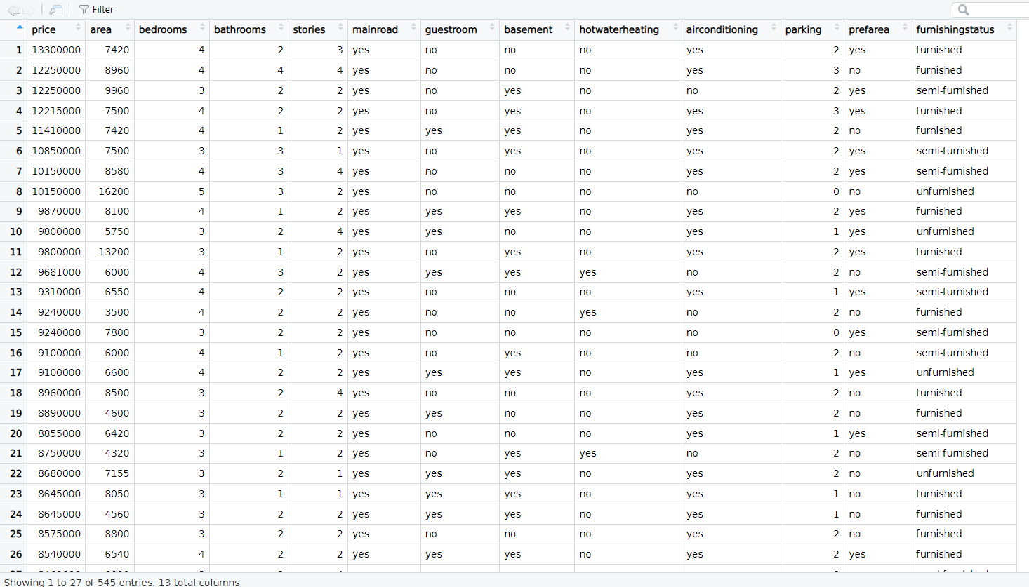

1. **Structure of the Dataset:**

Code: str(dataset)

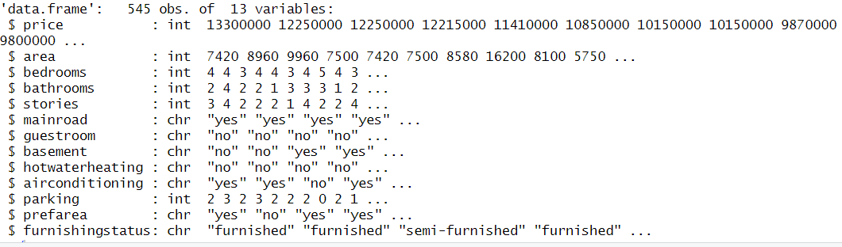

**3.Attributes**

Code:



**4.Check for missing values:**

Code:

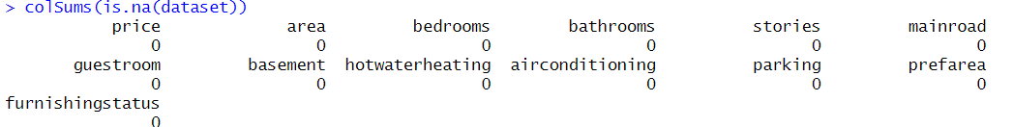

Set the predict variables and the target variable:

Code:

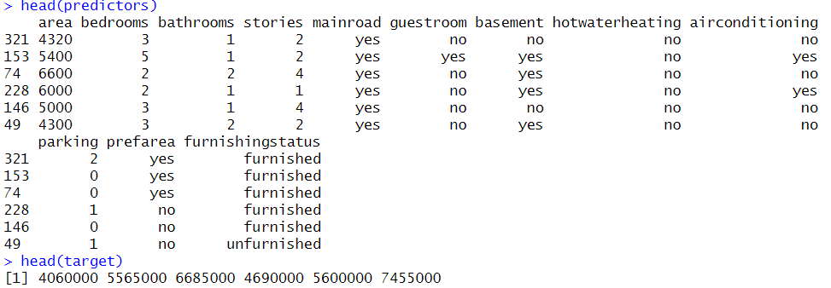

**6. Split the data into training and testing sets:**

split into training and testing sets using a 80:20 ratio

# Calculate the number of rows for training and testing

n_total <- nrow(dataset)

n_train <- round(0.8 * n_total)

n_test <- n_total - n_train

# Randomly shuffle the rows of the dataset

my_dataset <- dataset[sample(n_total), ]

# Split the dataset into training and testing sets

training_data <- my_dataset[1:n_train, ]

testing_data <- my_dataset[(n_train + 1):(n_train + n_test), ]

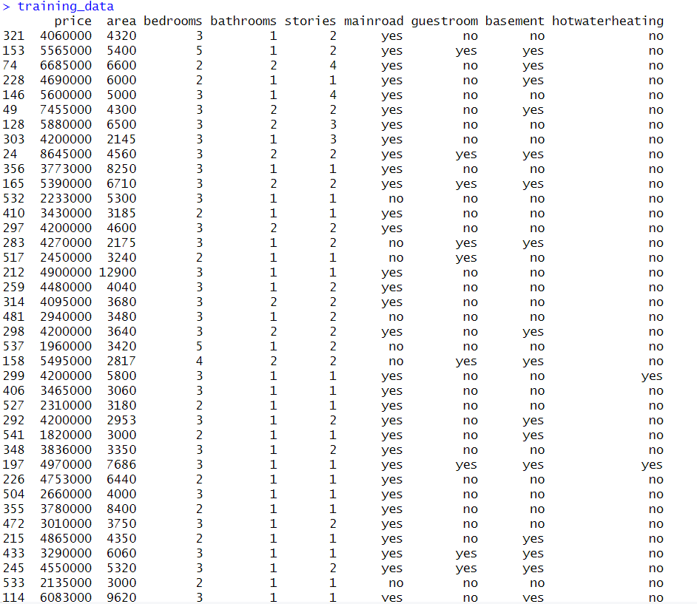

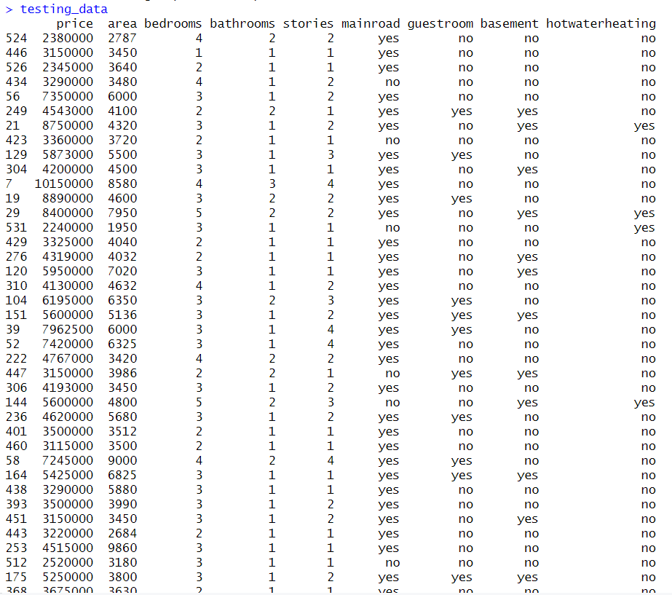

**7. implementing a k nearest neighbors and setting the values of k:**

knn_with_distance_measure <- function(train_data, test_data, train_labels, k, distance_function) {

n_train <- nrow(train_data)

n_test <- nrow(test_data)

predicted_labels <- character(n_test)

for (i in 1:n_test) {

distances <- numeric(n_train)

for (j in 1:n_train) {

distances[j] <- distance_function(test_data[i, ], train_data[j, ])

}

sorted_indices <- order(distances)

k_indices <- sorted_indices[1:k]

k_nearest_labels <- train_labels[k_indices]

predicted_labels[i] <- names(sort(table(k_nearest_labels), decreasing = TRUE)[1])

}

return(predicted_labels)

}

**8. Initialize vectors to store accuracies:**



**9.set the value of k and Apply k-NN for each k value and distance measure Apply k-NN with Euclidean distance, Manhattan distance & maximum distance:**

k_values <- c(3, 5, 7)

for (k in k_values) {

# Euclidean distance

euclidean_predictions <- knn_with_distance_measure(train_data, test_data, train_labels, k, distance_measure = "euclidean")

accuracy_euclidean <- sum(euclidean_predictions == test_labels) / length(test_labels)

cat("Accuracy for k =", k, "with Euclidean Distance:", accuracy_euclidean, "\n")

# Manhattan distance

manhattan_predictions <- knn_with_distance_measure(train_data, test_data, train_labels, k, distance_measure = "manhattan")

accuracy_manhattan <- sum(manhattan_predictions == test_labels) / length(test_labels)

cat("Accuracy for k =", k, "with Manhattan Distance:", accuracy_manhattan, "\n")

# Maximum distance

maximum_predictions <- knn_with_distance_measure(train_data, test_data, train_labels, k, distance_measure = "maximum")

accuracy_maximum <- sum(maximum_predictions == test_labels) / length(test_labels)

cat("Accuracy for k =", k, "with Maximum Distance:", accuracy_maximum, "\n")

Print the accuracy for the current k value:

accuracies <- c(accuracies, accuracy_euclidean, accuracy_manhattan, accuracy_maximum)

cat("\n")

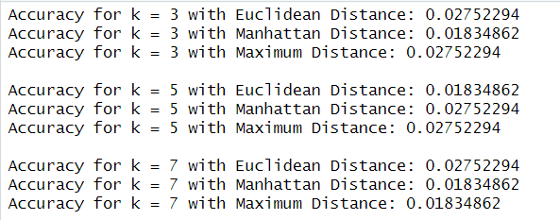

**10. Create a data frame for accuracies and plotting**

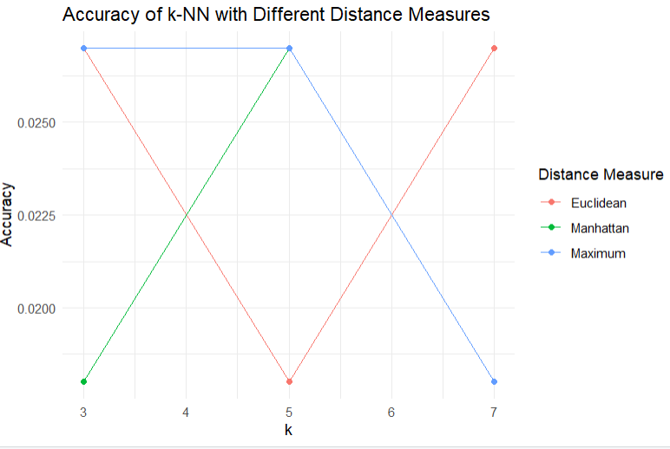

**11.conclusion**: The graph above shows how the accuracy of the knn algorithm varies with different values of k on using the 3 distance measuring methods (Euclidean, Manhattan, and Maximum Dimension). For all k value = 3,5,7 Maximum distance had the highest accuracy.